Project Report:

**Title:** LearnHub: Your Center for Skill Enhancement

TEAM ID: LTVIP2025TMID20434

# INTRODUCTION

## Project Overview

* + - LearnHub is a web-based online learning platform designed to help users explore, enroll in, and engage with educational content across various domains. It offers a seamless and user-friendly interface that supports personalized learning experiences. The platform leverages modern web technologies and integrates intelligent recommendation systems to suggest relevant courses based on user interests, learning history, and trending skills.

## Purpose

* + - The primary purpose of this project is to make skill development more accessible and effective through an intuitive digital platform. By incorporating smart recommendation features and interactive learning tools, LearnHub aims to enhance the overall learning experience. It simplifies the process of discovering and enrolling in suitable courses, helping learners make informed decisions to achieve their educational and career goals.

# IDEATION PHASE

## Problem Statement

* + - Finding the right learning resources online can be overwhelming due to the abundance of content spread across various platforms. Learners often struggle to identify quality courses that match their goals, skill levels, and schedules. There is also a lack of intelligent tools to personalize learning paths and guide users effectively through their upskilling journey.

## Empathy Map Canvas (For Learners on Online Learning Platforms)

1. **THINKS:** “Is this course really useful for my career or goals?”
2. **FEELS:** Overwhelmed by too many options and unsure about course quality or relevance.
3. **SAYS:** “I wish there was a platform that suggests the right course for me.”
4. **DOES:** Spends hours comparing platforms, reading reviews, and watching course previews.
5. **Goal:** To reduce time and effort spent on course discovery and provide smart, personalized course recommendations.

## Brainstorming

* **Course Search by Keywords and Categories**
* **Smart Course Recommendations**
* **Filter Options Based on Difficulty, Duration, and Cost**
* **Registration and Login System**
* **Progress Tracking and Certification**
* **Interactive Features**

# REQUIREMENT ANALYSIS

## Customer Journey Map

* User visits the website
* Registers or logs in
* Searches for courses
* Views filtered results
* Selects a course
* Enrolls and starts learning
* Earns certificate and logs out

## Solution Requirement

**Functional Requirements:**

* Course Search and Filtering
* Smart Course Recommendations
* Course Enrollment & Progress Tracking
* Certification System
* Instructor Dashboard

**Non-Functional Requirements:**

* Usability
* Security
* Scalability
* Performance

## Data Flow Diagram

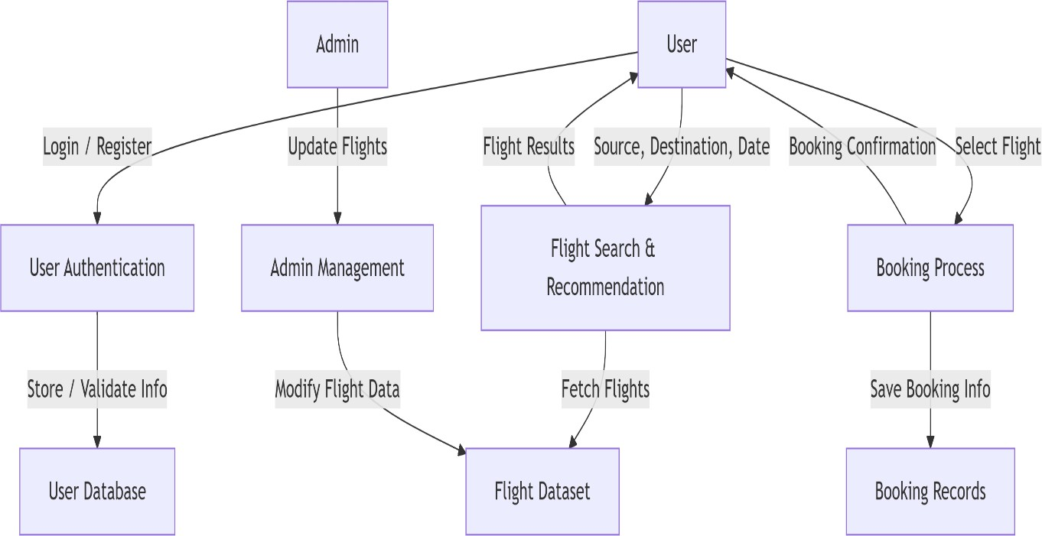

* 1. Technology Stack
* Frontend: HTML, CSS, JavaScript, Bootstrap
* Backend: Python (Flask)
* Database: MongoDB
* ML Model: Scikit-learn (Regression or Classification)
* Deployment: Localhost / Render / Heroku

# PROJECT DESIGN

## Problem Solution Fit

* + - Users need an easy, fast and intelligent way to search and book flights. Flight Finder addresses this need by combining traditional search with smart ML-based recommendations.

## Proposed Solution

Flight Finder proposes a user-friendly web application where users can:

* + - Register/login securely
    - Search flights with smart filters
    - Get ML-based suggestions for best timing or pricing
    - Book and receive confirmation
  1. Solution Architecture

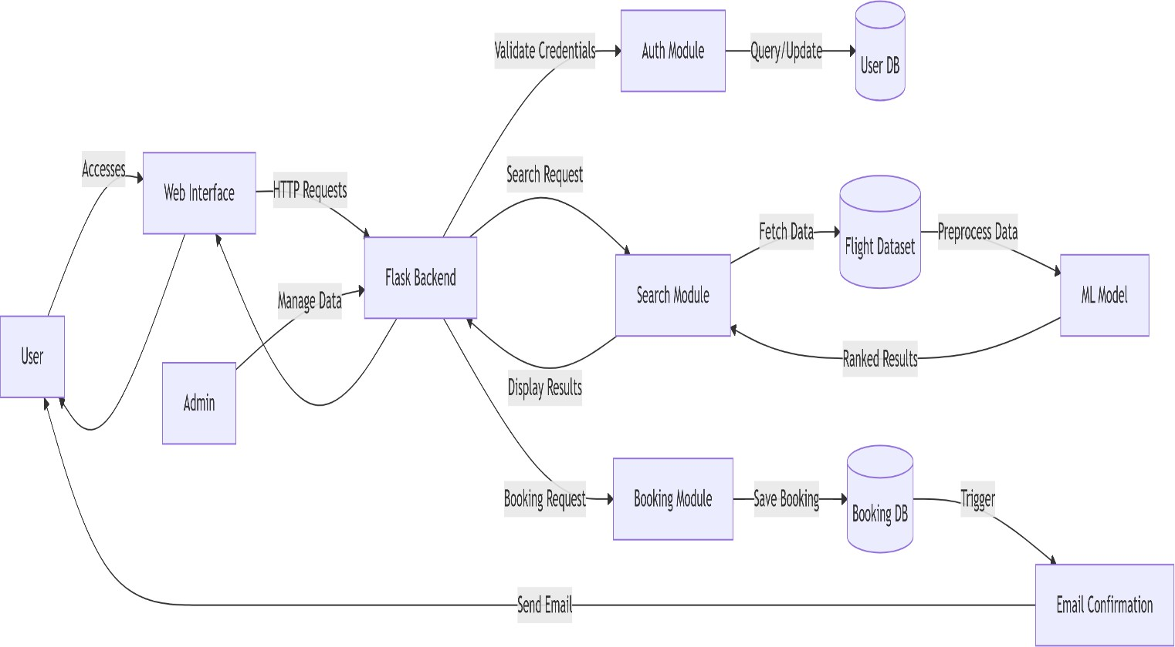

# PROJECT DESIGN

## Problem Solution Fit

* + - Users need an easy, fast and intelligent way to search and book flights. Flight Finder addresses this need by combining traditional search with smart ML-based recommendations.

## Proposed Solution

Flight Finder proposes a user-friendly web application where users can:

* + - Register/login securely
    - Search flights with smart filters
    - Get ML-based suggestions for best timing or pricing
    - Book and receive confirmation
  1. Solution Architecture



# 6.PROJECT PLANNING s SCHEDULING

## 6.1Project Planning

**Methodology**: Agile Scrum (2 Sprints)

**Team Velocity**: 12 Story Points/Sprint

**Total Effort**: 24 Story Points (10 working days)

### Sprint Plan

**Sprint 1:** Core features – User Authentication, Course Search & Filtering, Course Enrollment

### Sprint 2: Course Recommendations (ML Integration), Progress Tracking, Certification, UI Enhancements

# 7. FUNCTIONAL AND PERFORMANCE TESTING

### Key Metrics Findings:

* User-Centric Design Improves Engagement
* Progress Tracking Motivates Learners
* Interactive Features Enhance Learning Experience

1. **Testcases**
2. User Authentication:

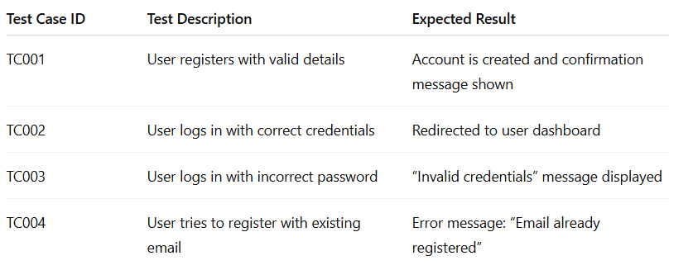

1. Course Search & Filtering

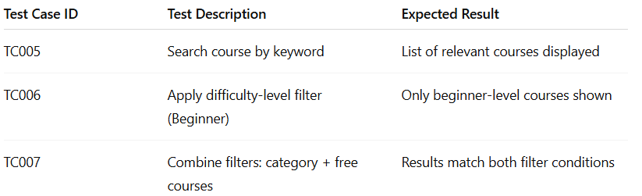

**3 Testcases**

1. User Authentication:



1. Course Search & Filtering



# RESULTS

## Output Screenshots

* Login

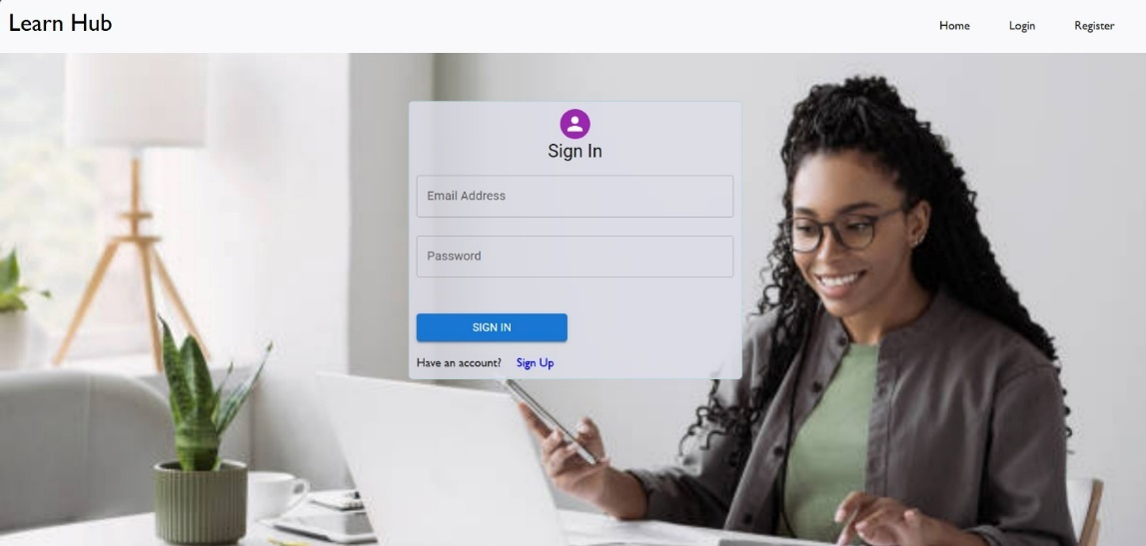

* Registration

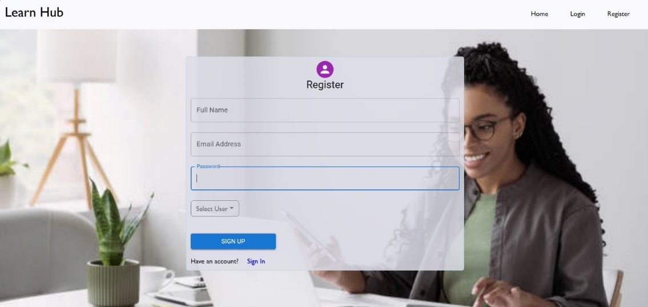

* Dashboard



* Teacher Dashboard:

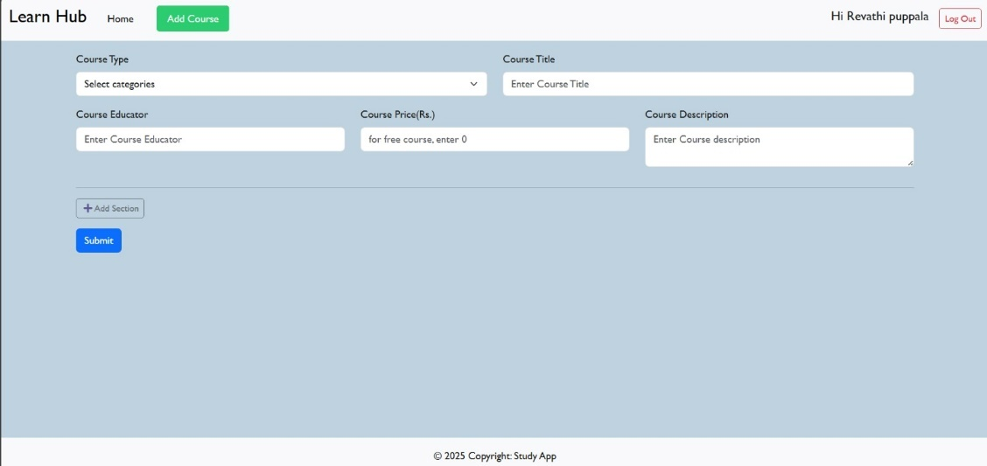

* Student Dashboard:

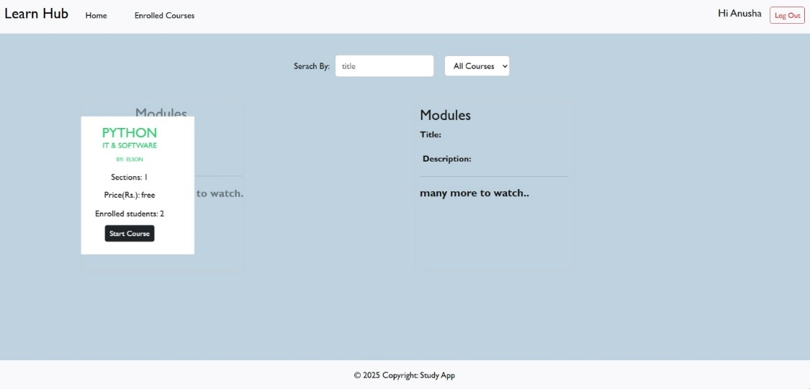

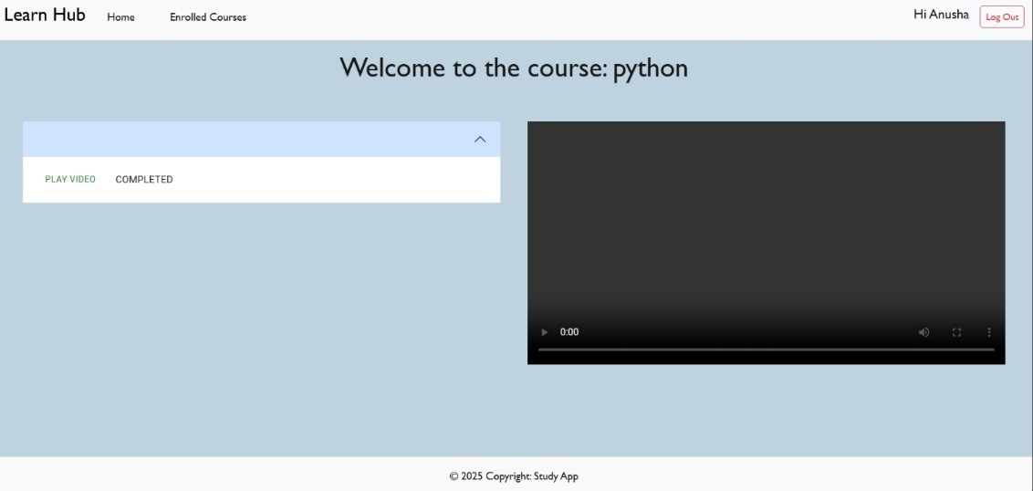

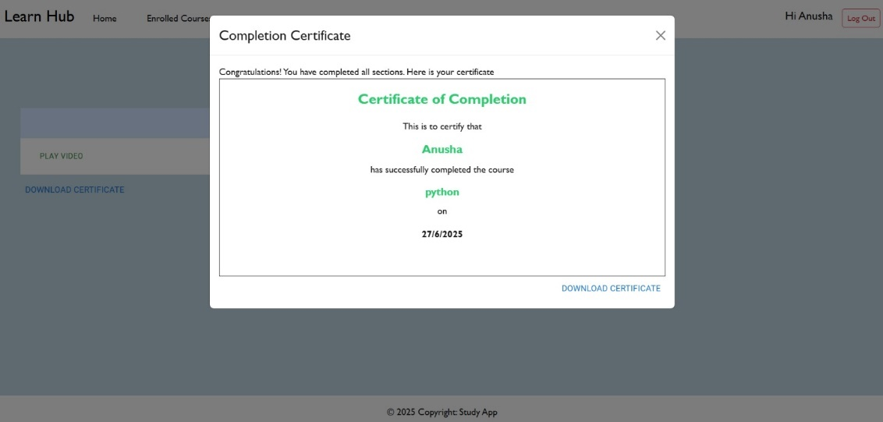

# ADVANTAGES s DISADVANTAGES

## Advantages:

* Personalized Learning Experience
* 24/7 Accessibility and User-Friendly Interface
* Scalable Architecture (MERN Stack)

## Disadvantages:

* Dependent on Internet Access
* Platform Content Maintenance
* Initial Development Complexity

# CONCLUSION

The Learn Hub project is a smart and user-friendly online learning platform that simplifies skill development. It provides personalized course recommendations using machine learning, enhancing the learning experience.The project demonstrates strong full-stack development using the MERN stack.Interactive features like quizzes, forums, and certification boost learner engagement.Overall, LearnHub makes learning more accessible, flexible, and goal-oriented for users.

### Key Achievements:

### Implemented User Authentication System:

### Secured login/registration with JWT and bcrypt for different user roles (Learner, Instructor, Admin).

**Progress Tracking and Certification Generation:**

* Allowed learners to monitor their learning journey and receive certificates upon completion.

**Progress Tracking and Certification Generation:**

* Allowed learners to monitor their learning journey and receive certificates upon completion.

**Added Interactive Learning Features:**

* Forums, quizzes, and discussion sections to boost learner engagement and collaboration.

**Future Enhancements**

**Live Classes & Webinars:**

* Integrate real-time virtual classrooms using WebRTC or third-party tools like Zoom/Google Meet APIs.

**Mobile Application**

* Develop a cross-platform mobile app using React Native or Flutter for better accessibility.

**Multilingual Support**

* Enable content and UI in multiple languages to reach a wider audience.

**Advanced Analytics Dashboard**

* Provide learners and instructors with insights into progress, engagement, and performance.

**Final Thoughts**

* + LearnHub is a powerful step toward making quality education accessible and personalized. By combining modern web technologies with machine learning, it enhances the user’s learning journey. With future upgrades, it can evolve into a complete digital ecosystem for continuous skill development.

# FUTURE SCOPE

### Gamification:

### Add badges, leaderboards, and rewards to boost engagement.

### Collaboration with Institutions:

### Partner with colleges and certification bodies for verified credentials.

### Advanced Analytics:

### Provide deep insights to learners and instructors for performance tracking.

### Monetization Models:

### Introduce premium subscriptions, course bundles, and in-app purchases.

* 1. **Chatbot Integration:**
* Use AI-powered bots for 24/7 learner support and course navigation help.

# APPENDIX

Source Code: [Add GitHub repo or attach zip]

Dataset Link: [Insert link or reference local file] GitHub C Demo Link: [Insert video or repo link